

**PAF-Karachi Institute of Economics & Technology (The Center of Excellence)**

**College of Computing and Information Sciences Software Engineering Course Project Proposal Form**

|  |  |  |  |
| --- | --- | --- | --- |
| ***Sno.*** | ***Stud. ID*** | ***Names*** | ***Course Name/CID*** |
| 1 | 61845 | JAWAD LODHI | SE/109120 |
| 2 | 61925 | SAAD ALI SIDDIQUI |
| 3 |  |  |
| 4 |  |  |
| 5 |  |  |  |

**Project Title:**_ { CAFÉ MANAGEMENT SYSTEM } now must have 5 CRUD based FEATURES]

1. **Motivation:**

*The motivation should clearly specify why this project is being made. :*

The main purpose of making this café management system is to Ensure the routine tasks of running your café and are completed with our café management system. Manage all aspects of your café business, from creating bill to printing receiptss.user can tick down items from the menu and can generate bill receipt.one of the main purpose of this project is make sure that the user is saving his time .

1. **Functional Features**

*Specify the features of your project which would make it significant for the evaluators.*

* 1. *If you are designing a project, which is in common use then you should specify those features which are making your project distinctive/unique in comparison with the existing ones “Totally a professional concept of implementing a CRUD based Product”.*
  2. *Indicate the utilization/benefits of your project “Will demonstrate implemention of all engineering activities expected under different pahses of SDLC on Product Development”.*
  3. *List down 5 unique but relevant Modules/Features for 5 members*
     1. *Module 1: Login Authentication (Common for all members)*
     2. *Module 2: creating bill and generating receipts*
     3. *Module 3: can save all the records / bills as a backup*
     4. *Module 4: user friendly interface / tick down menu*
     5. *Module 5:*
     6. *Module 6:*
  4. *Expected Detail of all Modules to be covered by each Member*

Member 1: Login + Module 2

1. **Demonstration of Create actitivty on Module 2**
2. **Demonstration of Review actitivty on Module 2**
3. **Demonstration of Update actitivty on Module 2**
4. **Demonstration of Delete actitivty on Module 2**
5. **Demonstration of Search actitivty on Module 2**

Member 2: Login + Module 3

1. **Demonstration of Create actitivty on Module 3**
2. **Demonstration of Review actitivty on Module 3**
3. **Demonstration of Update actitivty on Module 3**
4. **Demonstration of Delete actitivty on Module 3**
5. **Demonstration of Search actitivty on Module 3**

Member 3: Login + Module 4

1. **Demonstration of Create actitivty on Module 4**
2. **Demonstration of Review actitivty on Module 4**
3. **Demonstration of Update actitivty on Module 4**
4. **Demonstration of Delete actitivty on Module 4**
5. **Demonstration of Search actitivty on Module 4**

Member 4: Login + Module 5

1. **Demonstration of Create actitivty on Module 5**
2. **Demonstration of Review actitivty on Module 5**
3. **Demonstration of Update actitivty on Module 5**
4. **Demonstration of Delete actitivty on Module 5**
5. **Demonstration of Search actitivty on Module 5**

Member 6: Login + Module 6

1. **Demonstration of Create actitivty on Module 6**
2. **Demonstration of Review actitivty on Module 6**
3. **Demonstration of Update actitivty on Module 6**
4. **Demonstration of Delete actitivty on Module 6**
5. **Demonstration of Search actitivty on Module 6**
6. **Project Planning**

*Provide a detailed schedule for the successful completion of the project using Gantt charts for this purpose. (You may attach some extra sheet)*

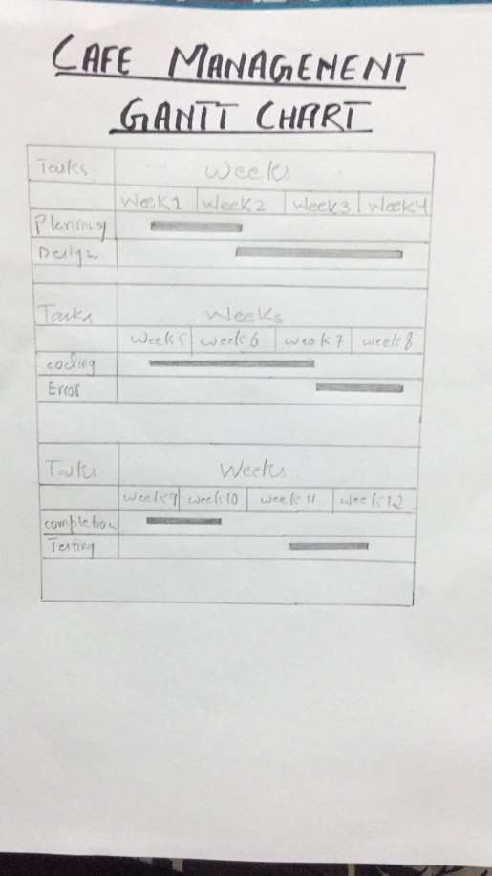

1. **Diagrammatic Representation of the Overall System**

*A detailed flow diagram of the overall system is needed.*

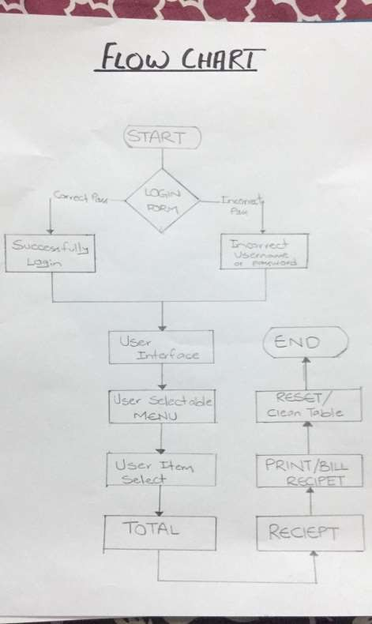

Student’s Signature: Date: _1_/ March/2022_